Sugar Sleuths
Working title: Camp Candy
GDD Group Version

1.0 High Concept
Camp Candy is a 2 to 4 player side-scrolling platformer, where players must discover clues to uncover who stole the camp’s Master Stash of candy.

1.1 Executive Summary
Inspired by games like Clue, Sugar Sleuths will have players try to discover who the camp culprit is by searching for information. Progression in Camp candy will be heavily influenced by character dynamics, as each player character has their own attitude, making the way the interact with other characters different.

1.2 Genre
Side-scrolling party game

1.3 Platform
PC

1.4 Key Features
· A side scrolling game inspired by Clue
· Supports 2 to 4 players
· Gameplay driven character dynamics
· Appealing art style

1.5 Art Style
Stylized cartoon

1.6 Setting
Modern day summer camp

2.0 Story
All the campers at camp [blank] know about the legend of the Master Stash. An ever-growing collection of confiscated candy taken from kids all summer. One-day word got out that the Master Stash had been stolen. The counselor [Eddy] told the children that there would be a reward for whoever could find the culprit and prove that they did it. Now it’s up to the campers to search the camp for clues and discover who stole the Master Stash.

3.0 Gameplay

3.1 Overview
In Camp Candy, two to four players will gather information and clues to find out who stole the camps Master Stash of candy from the counselor’s office. The player who finds the culprit first wins the game. In order to win, a player must determine: who stole the Master Stash, how they stole it, and where they hid it. If all the players guess wrong too many times, the game will be determined by who has the most points. The Master stash can be found in the camp for extra points.

Players will choose from a pool of 6 characters. They will take turns and be given a time limit to freely search the camp for clues and information. Camp Candy will require players to pass a single controller around while taking their turns. While outside, players will roam the Camp in a side scrolling fashion. During this time, players will be able to collect Chocolate Coins (CCoins), while dodging obstacles. CCoins can be used to barter with certain NPC’s for shortcuts, information, and clues. Collecting CCoins will also add to the player’s overall score, which will be tallied up at the end of the game.

When players enter Cabin Bunks or Recreational Areas (Rec Areas), they will be able to interact with NPC’s and search for clues. The first player to find the right clues that point to the culprit will win the game if they accuse the right person of the crime. Players may make up to three false accusations before failing the game.

While playing the game a player’s character will be in one of two states:

Active Characters/Players
The Active Character/player is the player whose turn it currently is, this is the player who has the controller, during this time the player has direct control of their character.

Limited Characters
When a player is waiting for their turn, their character is Limited. A Limited character will interact with the game world and the Active Player on their own (Without player input). A Limited Characters behavior depends on their attitude. If a player loses the game, their character will stay in the game as a Limited Character.

Score
Players will have their own Scores that will increase when accomplishing Attitude actions, finding items, collecting coins, or finding the master stash.

3.2 Camp Roads
Camp Candy’s gameplay area is a circle, players can traverse the whole map by either traveling right or left. While a player is traveling outside they are on the Camp Road. Camp Candy’s side scrolling portions take place exclusively on the Camp Road, and all players start the game on different parts of the Camp Road. While on the Camp Road, players will be able to run and jump. Players will also be able to collect CCoins while avoiding obstacles and dealing with Limited Characters.

Chocolate Coins
Chocolate Coins will respawn every [2] Rounds. Collecting Chocolate Coins will add them to your wallet, but will also boost your score.

Players will have [2 minutes] to get to a Bunk or Rec Area from the Camp Road. If a player is hit by an obstacle a portion of time will be taken away from their time limit, if a player’s timer reaches zero while on a Camp Road their turn will end prematurely.

3.3 Cabin Bunks and Rec Areas
Players will be able to advance in the game by entering Cabin Bunks and Rec Areas. There are no CCoins or obstacles in these areas, and the player will not be able to move.

There are 6 Cabin Bunks and 3 Rec Areas. Once a player enters a Cabin Bunk or Rec Area they will not be able to leave until their next turn.
Areas by Name
- Cabin Bunks
  - Cabin 1
  - Cabin 2
  - Cabin 3
  - Cabin 4
  - Cabin 5
  - Cabin 6
- Rec Areas
  - Mess Hall
  - Archery Range
  - Lake Side

When a player enters one of these areas they will be shown a vignette of the area. Players will be able to perform 1 of the following actions in these areas.

Investigate
Active Players will be able to select a part of the area to investigate for Tools.
If they find a Tool it will be put in their inventory. Their turn will end whether or not a Tool is found, most Cabin Bunks and Rec Areas will have more than one place to investigate, a player may only investigate one place per turn.

Ask for information
If there is an NPC or Limited Character in the same area as the Active Player, they will be able to question that character for information. Depending on their attitude, they will either help the player for free, or want something in return. If the player is successful in their questioning, they will receive a bit of information including but not limited to: I Saw [person] at the [place], there was something shiny at the [place], I heard a loud noise last night at the [place]. The players turn will end whether they successfully questioned an NPC or not.

Search for Master Stash
If the Active player has a certain Tool type, they will be able to use it to search the current Area for the Master Stash. Some, but not all, areas will have more than one place to search. If the player finds the Master stash their score will increase, but the game will not end. The players turn will end regardless if they were successful in finding the Master Stash.

Accuse
The Active Player needs to have at least one Tool in their inventory to make an accusation. Accusations can only be made in Cabin Bunks. The Tool they use to make the accusation must be a part of the accusation. For instance, if the Tool were a [shovel], their accusation would have to use the shovel, like so: “I believe [person], used the [Clue] to steal the Candy and [buried (Shovel)] it behind [Cabin 4]”. If the Accusation is correct the game will end. If the Accusation is wrong, The Active player will lose points, and they will be given a strike. If a player gets three strikes they will lose the game (Their character will remain in the game as a Limited Character). If the accusation is wrong the player will be given a piece of information proving them wrong. If the player’s accusation is wrong and they do not have three strikes their turn will end. In some cases, it is possible to find the Master Stash with an accusation.

Ask for Item
An Active Player can ask for a Tool (a physical clue) from an NPC or Limited Character who is in the same area as them. The Active Player will either receive the Tool or be challenged for it, depending on the attitude of the character the make the request to. If they are successful the Tool will be put in their inventory. Their turn will end regardless if they succeeded at the challenge or not.

Take a Shortcut
Some but not all areas will have an NPC who will offer the player a shortcut. This will either be free or cost Coins, depending on the NPC’s attitude. The players turn will end outside of another area.

NPC and Player Placement
Each playable character has a specific spawn location for the start of the game. All NPCs, however will be placed in random areas at the beginning of the game. They will be randomly placed in a new area every 2 rounds after that. Shortcut NPC’s will stay in the same areas for the entirety of the game.

NPC’s will never be placed in the same area as another NPC. This rule does not include Shortcut NPC’s or limited players.

3.4 Character Attitudes and Attitude Points
All NPC’s and playable characters will have 1 of 3 Attitudes which will affect how they interact with the Active player. NPC’s will only be found in Cabin Bunks and Rec Areas. Limited Characters can be found in all areas, including the Camp Road*. When a Limited Character successfully performs an Attitude action their score will increase.

Below are the Attitude types of Camp Candy.

Note: * A Limited Character can be found INSIDE the last area they ended their turn.
Limited Characters can also be seen OUTSIDE the last area they ended their turn.

Friendly
Friendly characters will often help the Active Player without asking for much in return.
They will interact with the Active Player in the following ways:

On the Camp Road
If a Friendly Limited Character (Limited Friendly) runs into an Active Character on the Camp road they will follow the character until they are either hit by an obstacle, or until they reach a Cabin Bunk or Rec Area. If the Active player is hit by an obstacle while a Limited Friendly is with them, they will not receive a time penalty, but the Limited Friendly will stop following them. The Limited friendly will also receive a score boost if the Active player is hit. They will receive a lesser boost if the Active Player makes it to their destination without being hit

When Questioned
A Limited Friendly will always give the Active Player Information for free. They will also receive a score boost when they give the Active Player information.

When Asked for a Tool
Friendly Limited’s have a 50% chance of giving up a Tool for free if asked. Otherwise they will ask to trade Tools instead. They will receive points either way, but will get more points when they give up a Tool for free. If a Friendly Limited does not have an Item, they will not ask to trade.

Tough
Tough Characters will try to get in the Active Player’s way.
They will interact with the Active Player in the following ways:

On the Camp Road
If a Tough Limited Character (Limited Tough) runs into an Active Character on the Camp road they will chase the player down. If the Limited Tough hits the Active player they will stop chasing the player and receive a score boost. The Active player will receive a time penalty.

When Questioned
Limited Toughs will not disclose information to the Active Player unless they are defeated in a Duel (See Duels Below). If the Active player wins, the Limited Tough will give them information. If the Limited tough wins they will not help the Active Player, and they will receive a score boost.

When Asked for a Tool
If the Limited Tough has a Tool in their inventory they will Duel the Active Player if they are asked for a Tool. If the Active Player loses and they have a Tool in their inventory they will give it to the Limited tough. If the Limited tough loses they will give a Tool to the Active Player.

Greedy
Greedy characters will only help the Active player if they give them CCoins in return.
They will interact with the Active Player in the following ways:

On the Camp Road
When a Greedy Limited Character (Limited Greedy) is on the Camp Road. They will collect CCoins. They will also get a score boost for every coin they collect.

When Questioned
Limited Greedys will only give the Active Player information in exchange for CCoins. If the player pays for the information, the Limited Greedy will receive the coins and a score boost.

When Asked for a Tool
If a Limited Greedy has a Tool, they will sell it for a large fee. Limited Greedys will sell both information and Tool to other Greedy characters for a higher price.

3.5 Duels
Duels are a game of rock paper scissors. They are initiated by Tough Characters. The Active player will be able to choose from Rock Paper or Scissors. Rock beats Scissors, Paper beats Rock, and Scissors beats Paper. Duels are only for one round. NPC’s and limited Characters actions will be automated.

3.6 Obstacle Types (Pending)

3.7 Tools
There are two Tool types. Tools that were used to steal The Master Stash (Getter Tool), these tools are used to determine how the culprit stole the Mast stash. The second Tool type consists of Tools used to hide the Master Stash (Stasher Tool). These Tools are used to determine where the culprit hi the stash. Stasher Tools can also be used to look for the Master Stash.

Getter Tool List
· Credit Card
· Drone
· Lock pick
· Suction Cup bow and arrow
· “Grabby” Arm

Stasher Tool List
· Fishing Pole
· Shovel
· Crow Bar
· Ladder

3.8 Shortcut NPC.
There are a total of 3 Shortcut NPC’s during a game. These NPC’s will spawn and stay in the same area. They will never change locations, and they will always spawn in the same location. When a player interacts with a Shortcut NPC, that NPC will offer to take them to a different part of the map. If a player uses a shortcut NPC, that player will be teleported to a different part of the map to a different area, but their turn will end, and they will not be able to enter that area until their next turn. These NPC’s will all look the same and their name is “???”. Shortcut NPCs will charge the player Coins for each use, if the player does not have enough coins. They cannot use the shortcut NPC

Steal
A Player can pay a Shortcut NPC to steal an item from another player.
When a player pays a shortcut NPC they will choose another player to steal from. The Shortcut NPC will then steal 1 random item from the player that was chosen

Shortcut NPC 1
Location Found: Cabin 4 and Lakeside
Shortcut to: Lakeside to Cabin 4, or Cabin 4 to LakeSide

Shortcut NPC 2
Location Found:Archery Range, and Cabin 5
Shortcut to: Cabin 5 to Archery Range or Archery Range to Cabin 5

Shortcut NPC 3
Location Found: Mess Hall and Cabin 2
Shortcut to: Cabin 2 to Mess Hall or Mess Hall to Cabin 2

4.0 Gamemaster Dialogue System (GMD)
The Gamemaster Dialogue (GMD) System, will from now on refer to how the game engine handles the random generation of the games win condition, and what each NPC will say during each game.

4.1 GMD Setup
Before each game, but after each player has chosen their character the GMD will perform Setup. Which will do the following:
- Pick 2 un-chosen playable characters and add them to the game as NPCs
- Pick 1 Random NPC (from a pool of 6) as the Culprit
- Pick 1 Random Getter Item (from a pool of 5) as the tool used to steal the candy
- Pick 1 Random Stasher Item (from a pool of 4) as the tool used to hide the candy
- Pick 1 Random Area (Cabin Bunk or rec area from a pool of 9) for where the candy was hidden
- Randomly Distribute all Getter and Stasher Items to NPCs and Areas
  - 4 Items will be given to NPCs (an NPC may only have 1 item)
  - 5 Items will be placed in Areas (an area can hold a max of two items)
- Each of the 6 NPC’s will be given 3 Basic Dialogues (see 4.2) that they will cycle through during game play. when they exhaust all of their dialogue, they will begin to repeat themselves.
  - NPC’s who have an item will have special dialogue for when that item is taken from them. This is Situational Dialogue (see 4.2) but it is not the only instance of situational dialogue.

The dialogue in Camp Candy is heavily dependent on the previous steps of the GMD Setup. Parts of what each NPC will say will change depending on GMD Setup.
For Example. Let's say the GMD chose:
- Cici as the Culprit
- The Lockpick as the getter item
- The Ladder as the stasher item
- The Mess Hall as the placed where the candy was hidden.

Now let's say that the GMD has allocated all of the items as such:
- The Lock pick is with Susan
- The Ladder is at the Lake Side
- The Drone is with John
- The Shovel is in the Mess Hall
- The Credit Card is with Cici
- The Bow and Arrow is with Phil
- The Grabby Arm is in Cabin 5
- The Crow Bar is in Cabin 1
- The Fishing Pole is Cabin 2

4.2 Dialogue
Keeping that in mind, understand that each NPC will have blank slots in their dialogue trees to accommodate the following Clue types:[AREA] [ITEM] [NPC] [CULPRIT]*
[STASHED AREA]**.

Basic Dialogue
So Susan will have a piece of dialogue like so: “I thought I saw an [ITEM] at [AREA]” or “[PERSON] was in [AREA]” this is Basic Dialogue. Basic Dialogue is a piece of dialogue that contains 2 Clues, and is always true:
- [NPC] and [AREA]
- [NPC] and [ITEM]
- [CULPRIT] and [STASHED AREA] ***
- [CULPRIT] and [ITEM]***
- [ITEM] and [AREA]

Note: * If an NPC uses a Basic Dialogue with [CULPRIT] they will simply say the Culprit NPC’s name, they will not reveal them as the Culprit outright. **This is the Area where the candy is hidden. *** These types of Dialogue

If The GMD decides that Susan saw the Crow Bar, then Susan will say “I thought I saw a Crow Bar at Cabin1” because the GMD already placed the Crowbar in Cabin 1 the Dialogue traces the item to the Area where that item was placed. If Susan saw the Drone, then her dialogue would choose a Basic Dialogue that contains [PERSON] and [PLACE].

Situation Dialogue
Another type of dialogue is Situational Dialogue. This dialogue contains 1 or no Clues.
This is the type of dialogue where an NPC greets the player character based on what character the player chose. Or if a character takes an item from an NPC, that NPC may say that they got that item from a [NPC] or [CULPRIT], or they found it at [AREA]. Or if the item is not a correct item, in this case lets say its the Drone from John, after getting it John would say “Alright you can borrow my Drone, be careful with it, ok?”

Culprit Dialogue
The last type of dialogue is Culprit Dialogue. Culprit Dialogue is just like Basic Dialogue or Situational Dialogue, but it's almost always false information or misinformation. Cici is the current Culprit for this example, so if she were to talk about the ladder, she would most likely say that it belongs to another NPC.. Culprit dialogue will always have at least 1 piece of dialogue that is tied to a correct item or place

Note: Players must talk to as many NPC’s as they can, eventually they will discover who is lying based on the information they hear. Cici will say that the ladder belongs to someone else. But other NPC will say that they saw her with it via [Culprit]/[ITEM] dialog.

To Reiterate: The player who guesses the 1.Culprit, 2. how they stole the candy, 3.how they hid, and 4.where they hid the candy wins the game. This is called an Actuation, and a player can only make an accusation under these conditions:
- The player is inside a Cabin Bunk (Rec Areas don’t count)
- The player has at least 1 getter or stasher item
- The item they use as “Proof ” MUST be part of their accusation

5.0 Player Turn Order

5.1 Rounds
A round in Camp Candy consists of all of the players’ turns. A full round begins from the first active player’s turn and ends at the very end of the last active player’s turn (or very beginning of the first active player’s next turn). A current round can end when either a player makes a correct accusation or all of the players fail to make the correct accusation three times each (basically, a total of 12 wrong accusations in one game for a full party). Each game has an unlimited amount of rounds until one of the above accusation criteria has been met.. Each one round should be about [8] minutes long at the very most. On their turn, the current active player can perform a number of actions in phases, most of which are categorized in locations. The chocolate coins respawn on the Camp Roads at the beginning of each round. The NPCs change locations (they go to random locations) every two rounds.

5.2 Turns
Each player has one turn per round. [There’s a set order of turns that the players will follow. The order is dependent on the characters chosen to play in the current game.] The players have, at most, two minutes to change location via walking, find clues, search for the Master Stash, question an NPC or a limited player character, or make an accusation to solve the mysterious theft of the Master Stash. Active players have the option to end their turn whenever they see fit. Turns can also end if the player loses too much time, detailed in Phase One below.

Each player may find that they have additional points, on their current turn, for their successful limited player actions, off of their turns/on other players’ turns.

5.3 Phases
There is a maximum of two phases per one turn. The first phase must occur, as it is the beginning of the turn. The first phase takes place on the Camp Roads and the second [optional] phase takes place in either the cabins or recreational areas, depending on where the active player wants to go. During these phases, the active player can encounter any limited character (of any type) and NPC (who also have attitudes).

Phase One: Side-Scrolling Adventures/Exploration
This phase is the necessary beginning of the active player’s turn. The active player will always start outside of the last cabin or recreational area they ended their last turn in. They will be located on the camp road just outside of the aforementioned interior. During this phase, aptly dubbed the side-scrolling adventure phase, is the side-scrolling aspect of the game. The active player is able to collect chocolate coins (or CCoins) by walking and jumping around the area.

Limited players with the Greedy attitude are able to take CCoins from the area, thus earning more points that the active player could’ve gained. This also leaves the active player with less CCoins to collect.

There are obstacles (stationery, such as a prop, and A.I., such as an animal adversary) for the active player to avoid in this phase. Attacking enemies are able to take time away from the player and shorten their turn. [Time during their turn is a synonym to player health in this game. It’ll always be a full tank by their next turn] If the player continues to lose time, the turn will end early/prematurely, forcing them to not partake in the second phase of the turn.

This phase ends when the active player doesn’t end their turn (either voluntarily or due to one of the circumstances listed) on the Camp Road and goes into a cabin or recreational area. This begins the second phase of their turn.

Phase Two: I Spy a Clue
This is the optional yet vital second phase. This phase may or may not occur depending on the active player’s actions during their first phase of their turn. If they have not lost all of their time on the Camp Roads from the obstacles, or took any shortcut, this phase will occur when the active player enters within a cabin or recreational area. The active player can interact with or question an NPC or limited player for information (non-physical clues) or tools (physical clues), investigate the location for tools, search for and/or collect the Master Stash, or make an accusation.

Only in this phase may an active character make an accusation. This is what makes this phase incredibly important. An accusation can only be made during this time because the active character would be in a cabin (an accusation can only be made in a cabin, not in recreational areas), with a tool they believe was involved with the crime. Whatever tool(s) the active player has, it must be mentioned in their accusation. The active player’s turn ends when an accusation is made, whether it be correct or wrong.

If an active player doesn't have any tool for an accusation, they can investigate their current location for tools and the Master Stash. Each location has, at the very minimum (or very most) two areas open for investigation. The active player can investigate only one area in their current location before ending their turn, whether or not they are able to find a tool of the Master Stash.

If the active player is able to locate the Master Stash, they must wait another turn to attempt to collect it, if they wish to gain bonus points. The active player can attempt to collect the item if they have a tool in their inventory. Their turn ends with a successful or unsuccessful attempt. The success is solely dependent on the tool needed in the area the Master Stash is stashed away.

NPCs and Limited players are located within cabins or recreational areas. Limited players are always inside of the area they ended their previous/last turn. The active player can ask/question an NPC or limited player for one of two things: information or a tool. The active player, whether or not they successfully gain a clue in their attempt, ends their turn here.
Information clues are successful more often than not, as they are non-physical clues. The format of the clue given by an NPC or limited player could be (though it is not limited to): “I saw [person] at the [place], there was something shiny at the [place], I heard a loud noise last night at the [place].” NPCs and limited players will have a limited number of clues to tell. There could be a point when the active player will encounter the same clue from an NPC or limited player if they continue to ask for information. This is convenient for players that wish to hear a clue that was previously mentioned (to refresh their memory).

Asking for a tool yields a lower success rate when compared to asking for information. There is a very limited number of tools to find in the game; there are nine tools to be discovered, but only two are involved in the crime (per game, of course).

Limited players with the Tough attitude are most likely to end the active player’s turn. If the active player fails to defeat a Tough limited player (nicknamed the Limited Tough) in a duel, their turn ends early/prematurely .

If an active character wishes to interact with a Greedy limited player (nicknamed the Limited Greedy) they would have to exchange their own CCoins for the information or tools they wish to obtain. If they do not have the funds necessary for the clue they seek, their turn does not end. The active player can perform a different action. If an active player does purchase a clue from a Limited Greedy, their turn ends.

The active player can also interact with a Friendly limited player (nicknamed the Limited Friendly). The active player can obtain free information or a tool from a Limited Friendly. A Limited Friendly will not give an active player a tool if they are not carrying a tool. Limited Friendly's gain points for giving an active player information and taking a hit for them (when the active player is hit by an enemy, Limited Friendly's soften the blow).

Only in the cabins or recreational areas. can an active player access shortcuts. The shortcuts can take the active player from one end of the camp to another, cutting down the time necessary to just walk over to the destination in mind. These are not entirely free for the active players to abuse however. The active player must pay a fee to an NPC Greedy in order to use the shortcuts. If there is an NPC Friendly, the active player does not need to pay a fee. Regardless of which NPC takes the active player through the shortcut, using a shortcut will end their turn.

5.4 Game Flow in Brief
Inside Area Gameplay
When inside an area the player can take 1 of the following actions:

Make Accusation (in Cabins Only)
If the player has an item in their inventory they may make an accusation.
If they are correct they win the game. If they are wrong then they get 1 strike, and their turn ends. If they get three strikes then the lose the game. But their character will remain as a limited character. (See Section)

Search for item
The player can search a part of the cabin for an item. A prompt will appear telling them if they’ve found anything or not. If they find an item it will be added to their inventory. Their turn will end whether or not they find anything.

Search for the Candy Stash.
If the player has a ‘Stasher type item, they may search the current area for the candy stash, using 1 stasher item from their inventory. A prompt will appear telling them if they’ve found anything or not. If they found the stash they will get extra points.Their turn will end whether or not they find anything.

Shortcut NPC
If the shortcut NPC is in the same area as the player, the player can talk to the NPC to be taken to a different area. The Game will ask the player if they are sure they want to use the NPC. If the player answers “no”, then they will be taken back to the main area menu. If the player answers yes, they will teleported to a different area. They’re turn will end when they are teleported, they will not be able to enter the new area until their next turn.

Main NPC or Limited Player
If there is an NPC or Limited Player in the same area as the active player, then the active player may interact with them in the following ways:

Ask NPC for Information
The player can ask an NPC for information. The NPC will react differently depending on their attitude:

Friendly
Friendly characters will give the player information for free. The players turn will end after they receive the information.

Greedy
Greedy characters will charge the player coins for information. When the player asks them for information, they will tell the player how many coins they want. If the player chooses to pay the Greedy character they will receive information and their turn will end. If they choose not to pay the Greedy Character, they will be taken to the main Area menu.

Tough
Tough characters will duel the player for information. If the player chooses to duel the Tough character, they will play a game of Rock Paper Scissors. If the player wins, they will get information from the Tough character and their turn will end. If the player loses then their turn will end and they will not receive any information. If the player chooses not to duel the Tough character, they will be taken back to the main area menu

Ask NPC For Item
The player can ask an NPC for an Item. The NPC will react differently depending on their attitude:

Friendly
Friendly characters will want to trade for items. If the player has no item to trade, they will be taken to the main area menu. If the player has any items in their inventory, the Friendly character will choose 1 item at random from the player's inventory that they want to trade. If the player chooses to trade, then they will trade items with the Friendly character and their turn will end. If the player chooses not to trade, they will be taken to the main area menu.

Greedy
Greedy characters will charge the player coins for items. When the player asks them for an item, they will tell the player how many coins they want. If the player chooses to pay the Greedy character they will receive an item and their turn will end. If they choose not to pay the Greedy Character, they will be taken to the main Area menu.

Tough
Tough characters will duel the player for items. If the player chooses to duel the Tough character, they will play a game of Rock Paper Scissors. If the player wins, they will get an item from the Tough character and their turn will end. If the player loses then their turn will end and they will not receive an item. If the player chooses not to duel the Tough character, they will be taken back to the main area menu.

6.0 Player characters and NPC’s

6.1 Player Characters

Theo Gummy
Camper
Age:10
Attitude: Friendly
Starting Area: Cabin: 1

Bonnie Bubble
Camper
Age:11
Attitude: Friendly
Starting Area: Cabin: 2

Samuel Pepper
Camper
Age:12
Attitude: Greedy
Starting Area: Cabin: 3

Lacey Twist
Camper
Age:13
Attitude: Greedy
Starting Area: Cabin: 4

P.B
Camper
Age:14
Attitude: Friendly
Starting Area: Cabin: 5

Francis
Camper
Age: 15
Attitude: Greedy
Starting Area: Cabin 6

6.2 NPC’s
CiCi
Counselor
Attitude: Friendly

John
Counselor
Attitude: Greedy

Phil
Counselor
Attitude: Greedy

Susan
Camper
Attitude: Friendly

??? (Shortcut NPC)
Camper
Attitude: N/A

7.0 UI WireFrame Mockups (with placeholder art)

Title / Main Menu
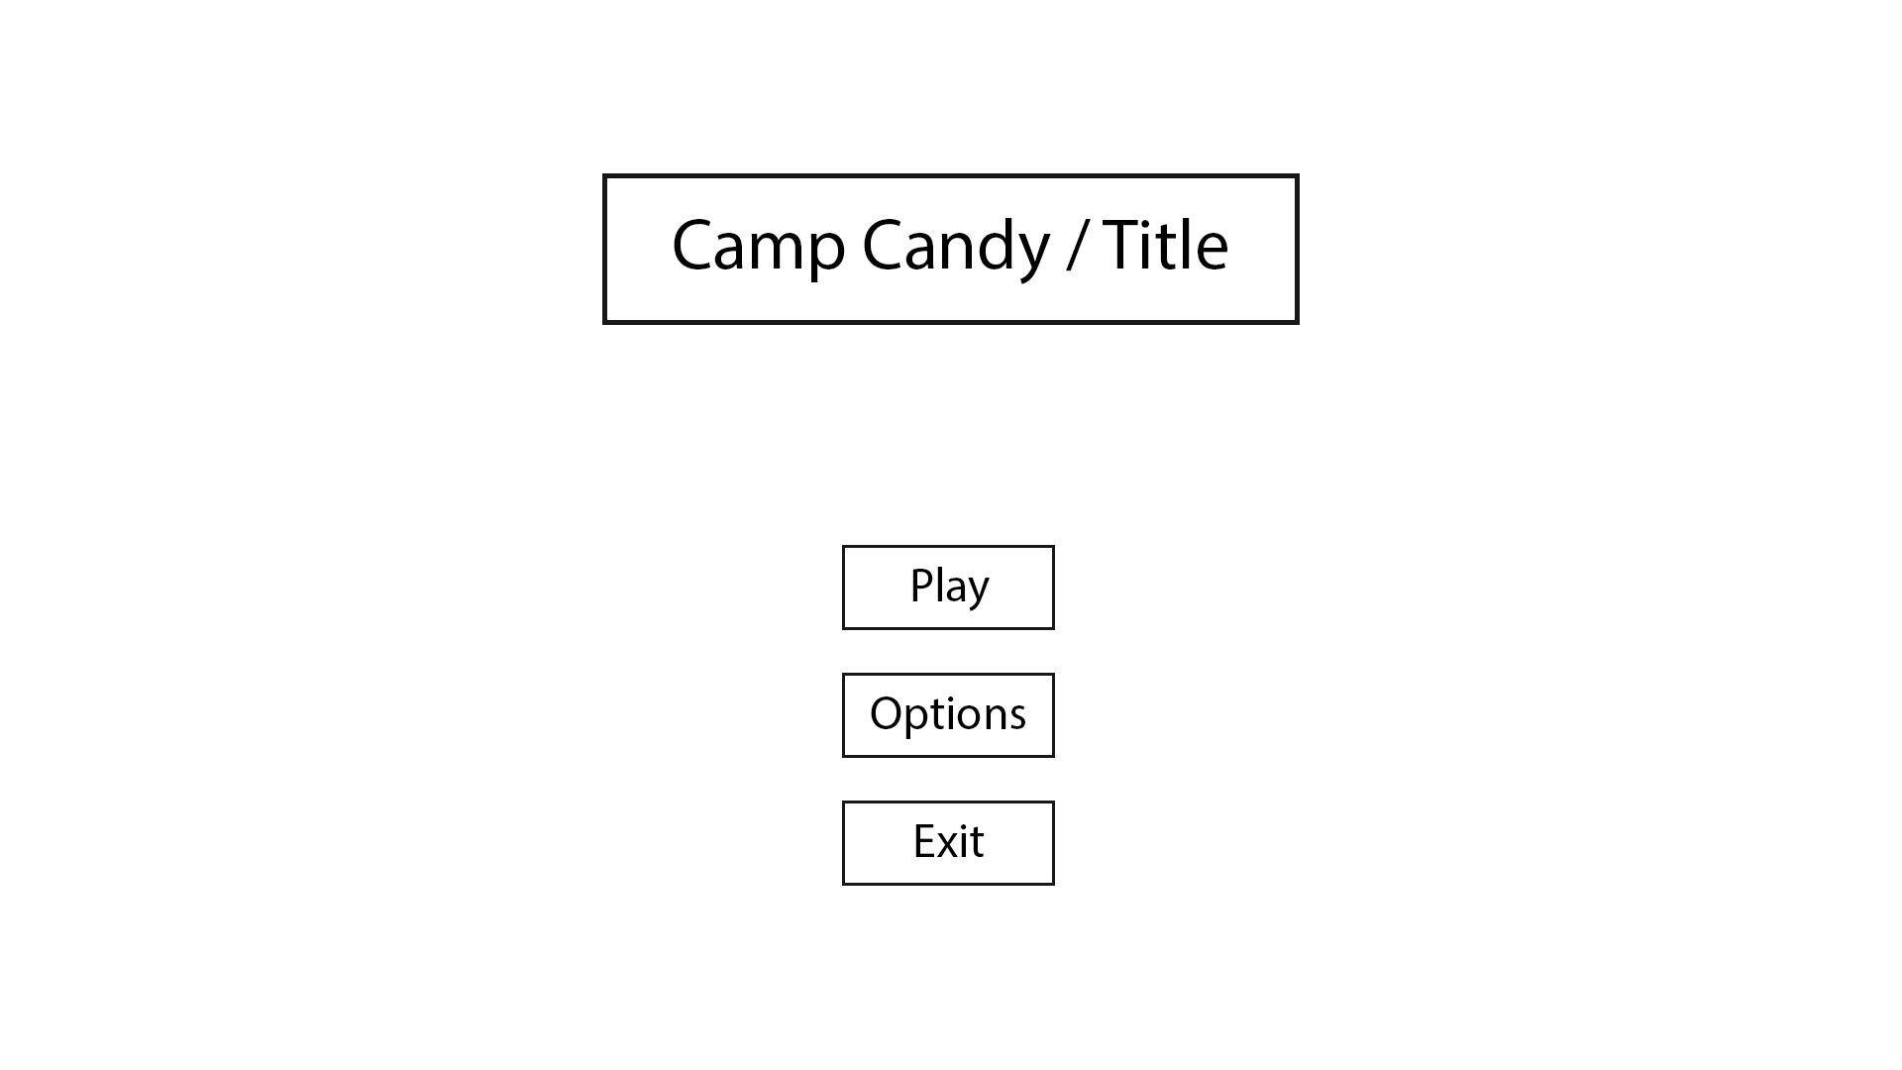
The title of the game (most likely not going to be Camp Candy, which is our working title) sits at the middle top of the screen. The three buttons are as follows: play/start/start game, options/settings, and exit/exit game. The play button, when clicked, transitions to the character select. The options/settings (if we implement these features) button transitions to an options menu with the usual settings to alter (SFX, BGM, skip CPU turns, etc). The exit button will simply close the game.

Art
The title will sit on the welcoming committee of the camp. When the play/start button is pressed, the camera will fly (probably not too fast) into the camp, under the entrance, and stop near or in front of the characters’ cabins. The background will have art as well, it’s not to be a blank background.

Character Selection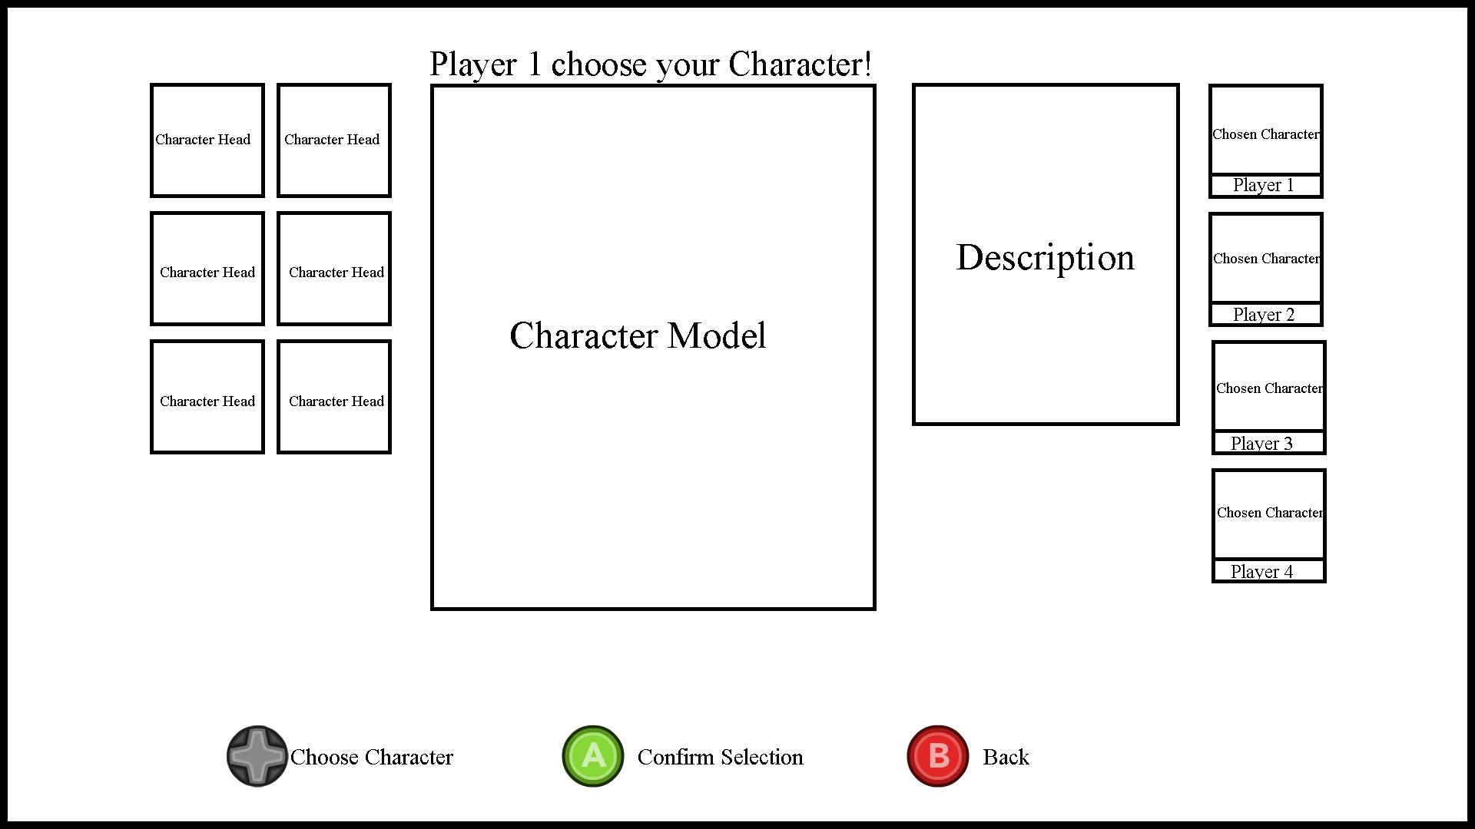
Text at the top of the screen will indicate which player is selecting a character via “Player ##”. ## represents the number, which ranges from 1 to 4. When the player is currently choosing, the character currently under the cursor (in this case, an outline) will show the character’s photo (or candy icon) and short description. The other five characters will not be highlighted, they will be shaded to put them more in the background. When a character is selected, the next player will automatically skip over that character and go to the next one. A selected character will be shaded out, but his/her description will be hidden away.
The controls for this screen will be in the corner, about 75% transparent.

In-game Map Overlay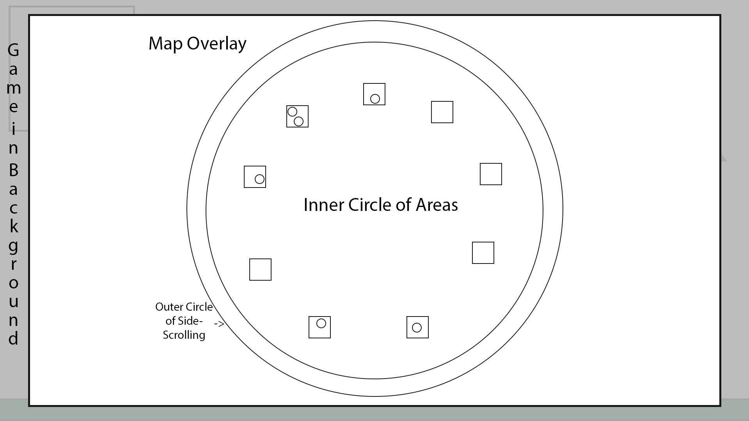
This is solely an overlay that sits on top of the game screen. The active player can press a button to activate the overlay (maybe with the right trigger button). The whole map can be seen here. There will be markers of each character’s icon in-game for every player and NPC. The NPC markers update every two rounds. The active players’ markers will update each turn, as the players will most likely be moving from place to place.

During Gameplay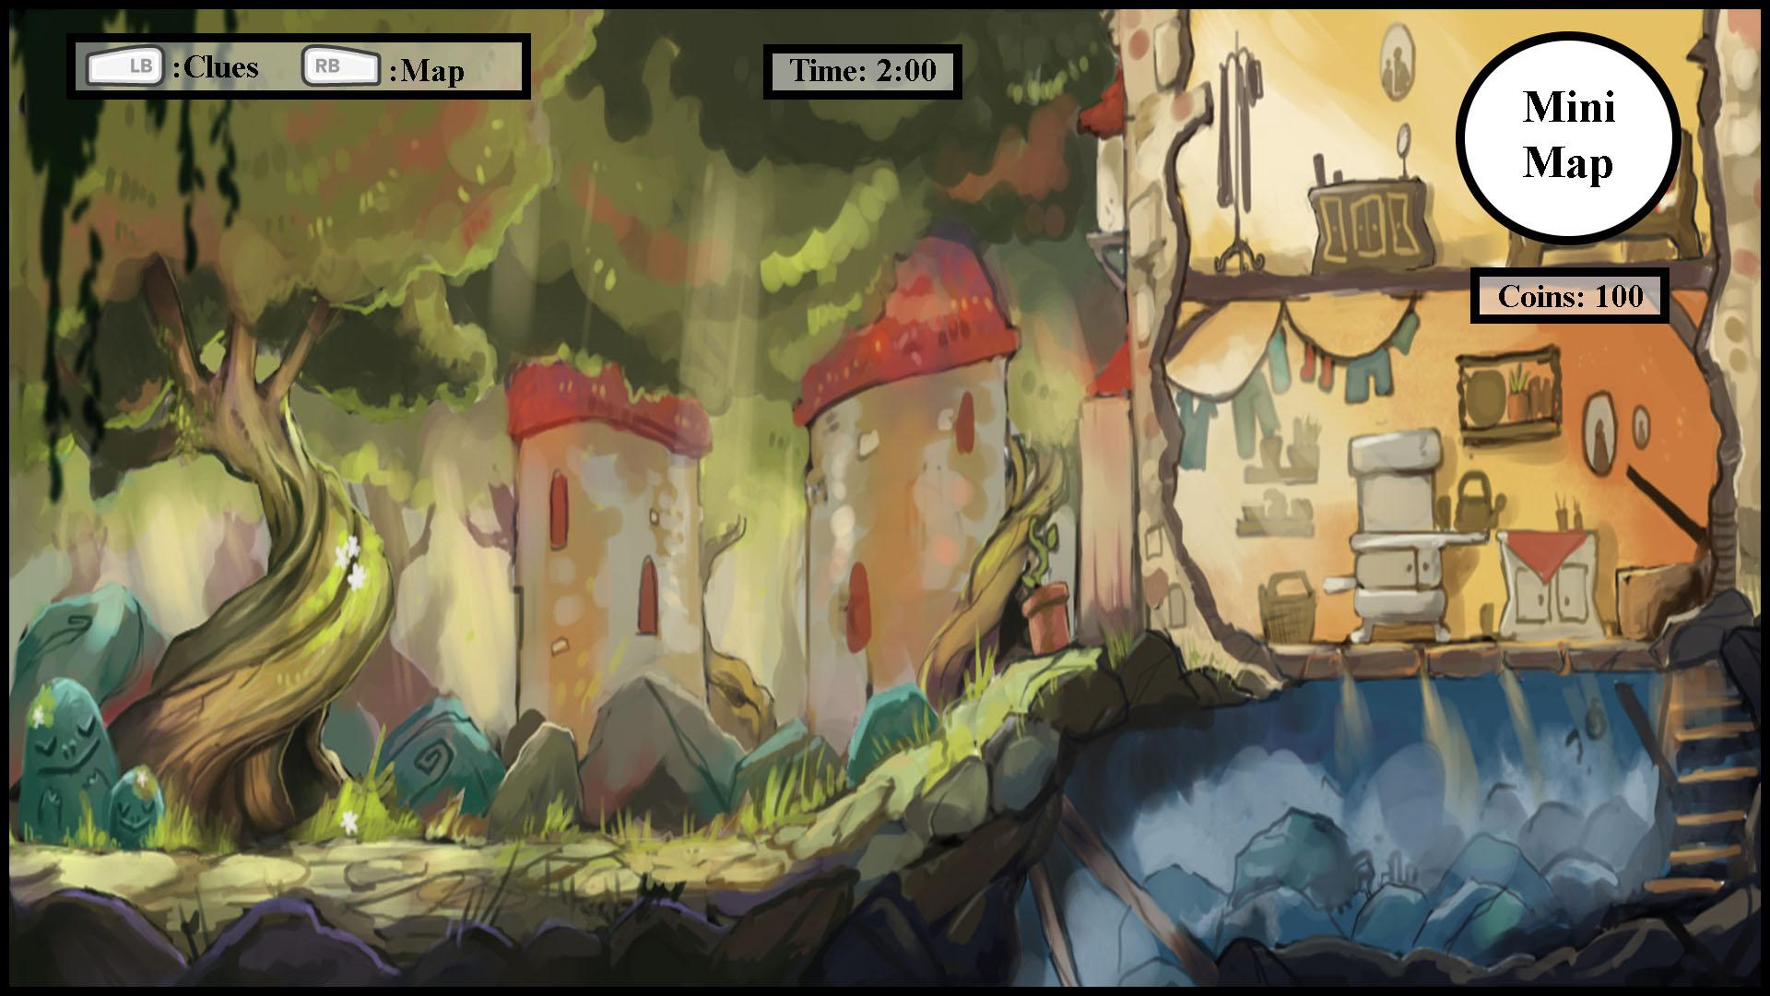
During Gameplay the player will see: How much time they have left on their turn, how many coins they have, a mini map, and button prompts for showing the main game map, and known NPC Clues.
Entering a Cabin Bunk or Rec Area 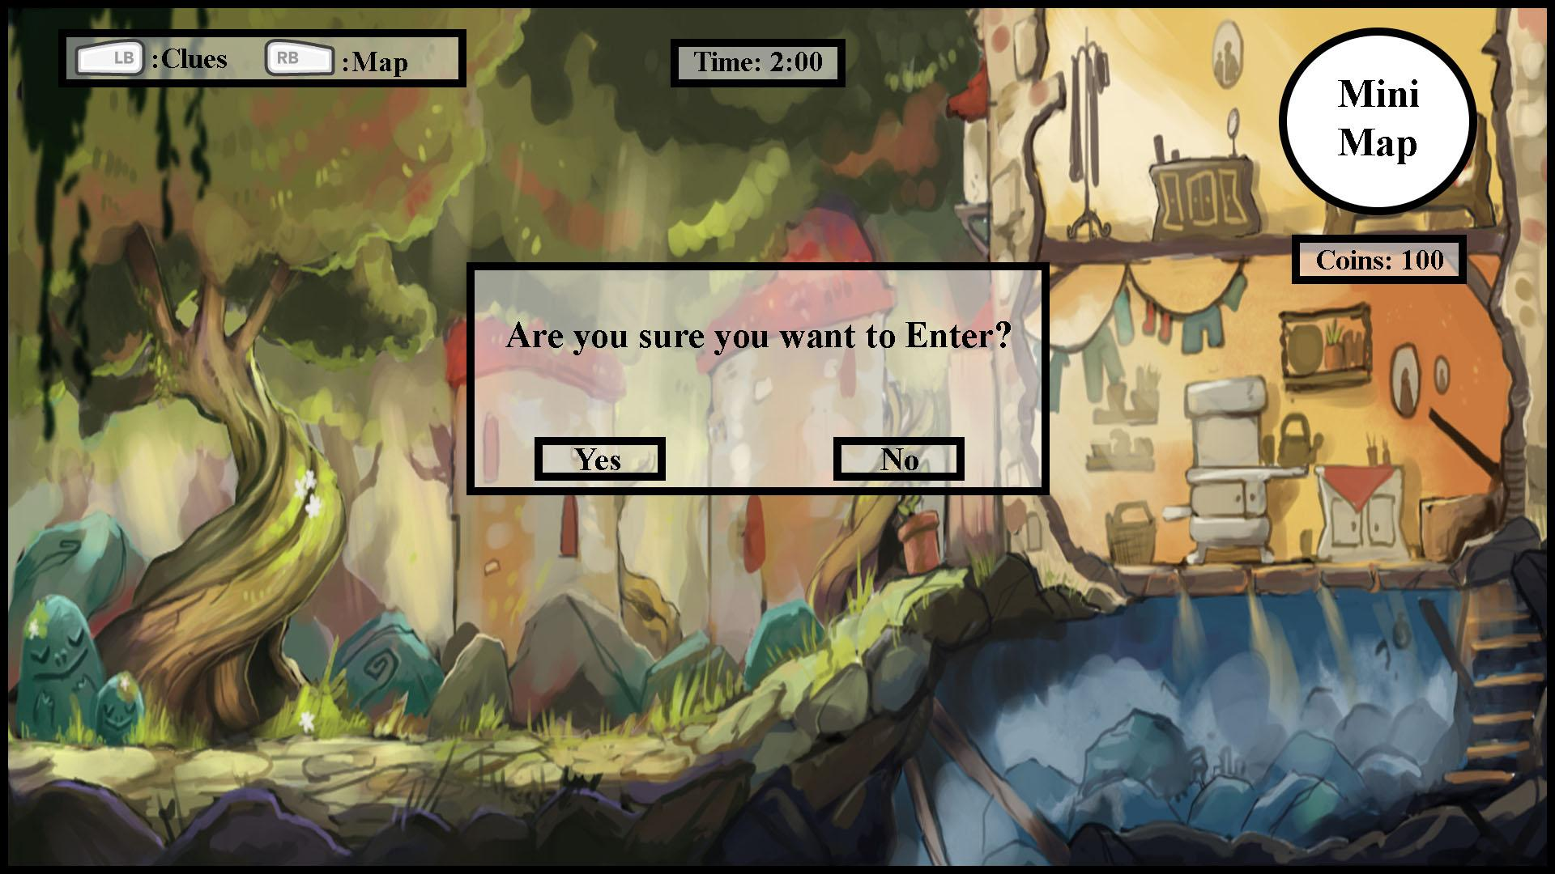If the player tries to enter a Cabin Bunk or Rec Area, this prompt will appear to ask them if they are sure they want to enter the area. If the choose “yes”, they will enter that area, if they choose “no” they will resume Camp Road Gameplay. The players Turn Time will be paused during this time.
Pause Menu 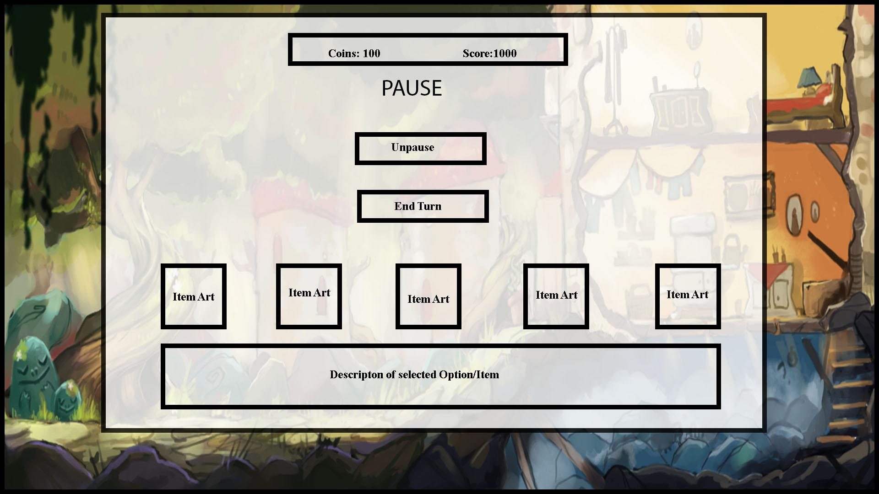
When the player presses the pause button, they will be taken to the pause menu. Here they can move the cursor to UnPause the game or end their turn early. On the pause menu the current player’s inventory will be shown. If the player moves the cursor to one of their inventory slots, a description of that item will appear below it. The players Turn Time will be paused during this time
Known Clues 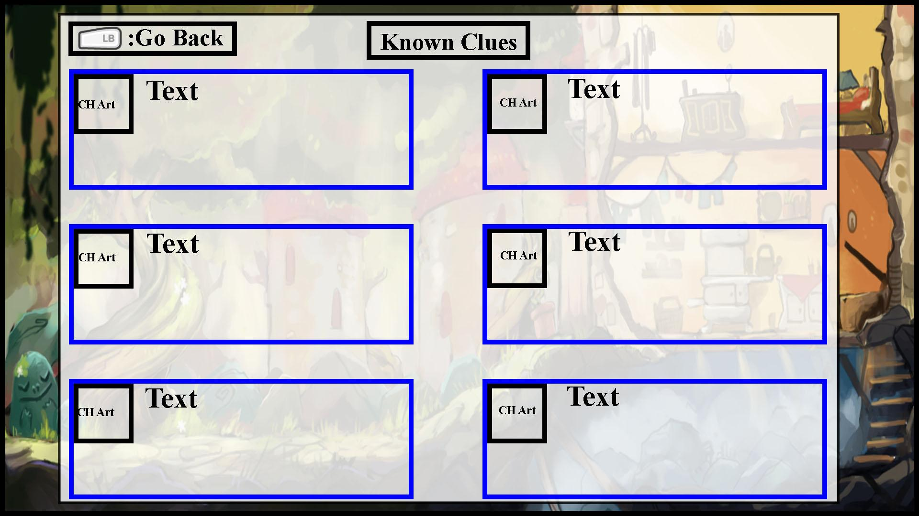
If the player press’s the [Left Bumper] during Camp Road gameplay, they will be taken to this menu. Here is where the last piece of information any of the 6 NPC’s have said will be recorded. If an NPC offers up a new piece of information, then their place on this menu will be updated to reflect that information. Only one piece of information will be displayed per NPC, this menu will be updated whenever a NPC gives new information. The player will have to press the [Left Bumper] again in order to return to gameplay. This menu will pause gameplay.
Entering Bunk / Rec Area (With/Without NPC)
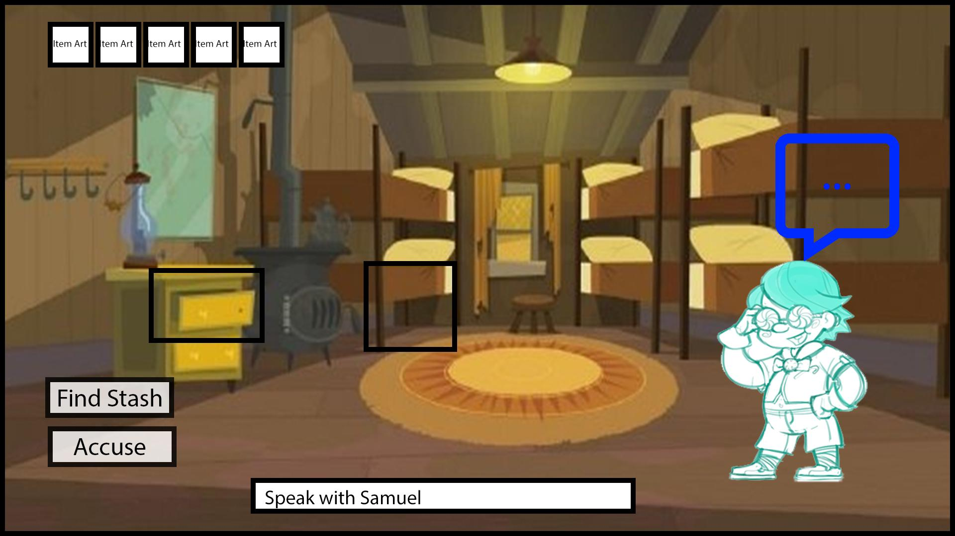
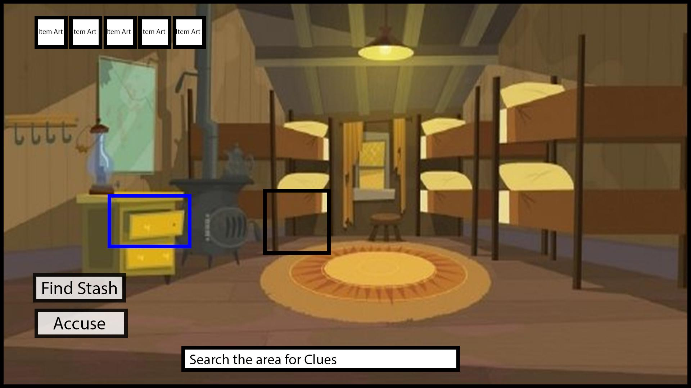

(Entering Cabin / Rec Area) When the player enters a Cabin or Rec area they will have the option to: Look For the Hidden Stash, Accuse the Culprit, and Search the designated points of the area for clues. If There is a NPC or Limited Player in the same area they will appear in that area, and the player will be able to interact with them as well. The player will be able to choose what they want to do, whichever option they move the cursor to will become highlighted. There will be a small description box that gives a short explanation of the point that is currently highlighted. The player's current Inventory will be displayed on the upper left hand corner inside areas

Searching For Clues.
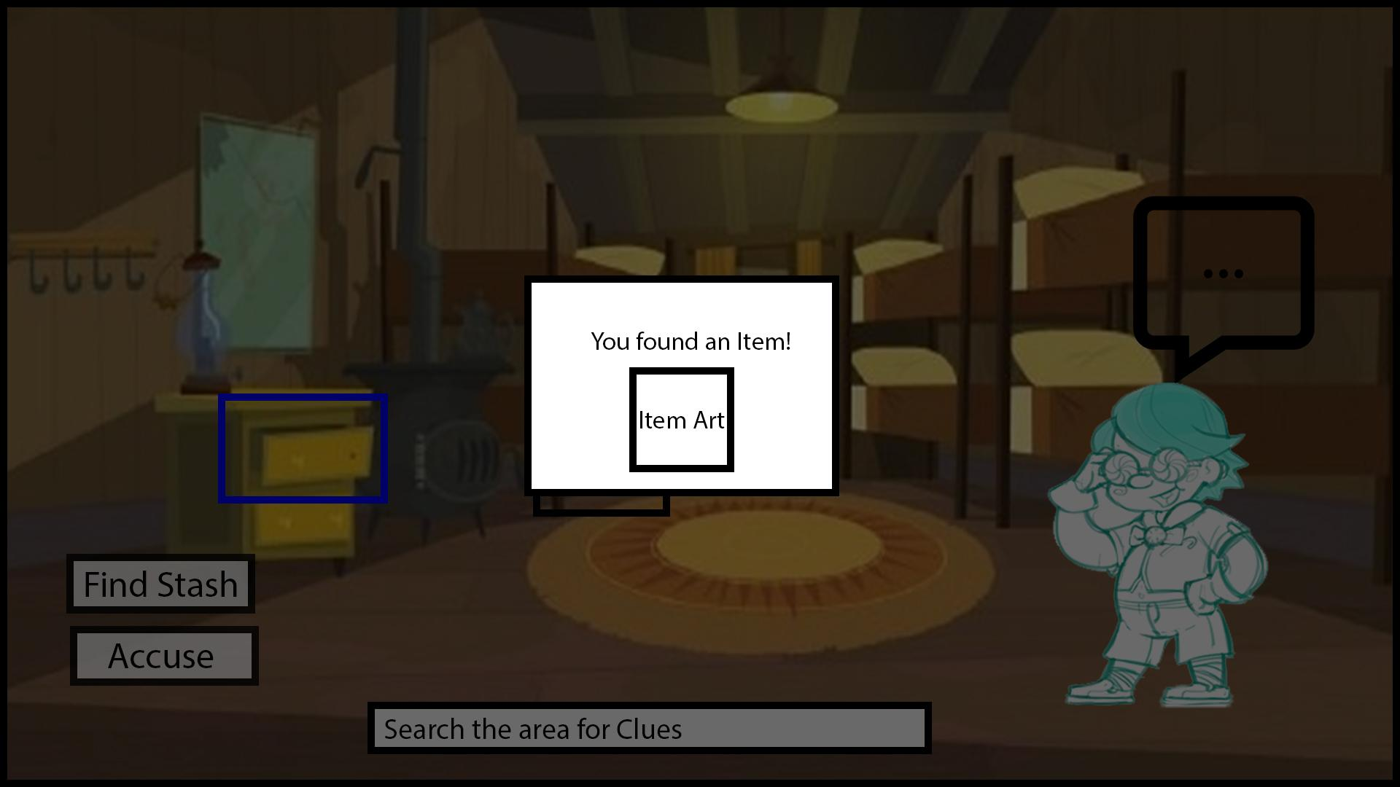

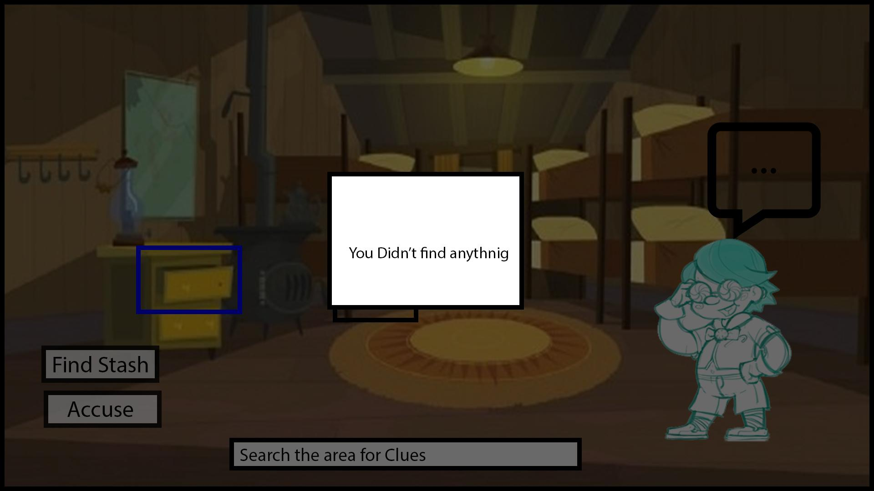
If the player chooses to search a point for clues. The screen will dim, and the results of their choice will be shown. They will either find an item or not.

Look for Stash
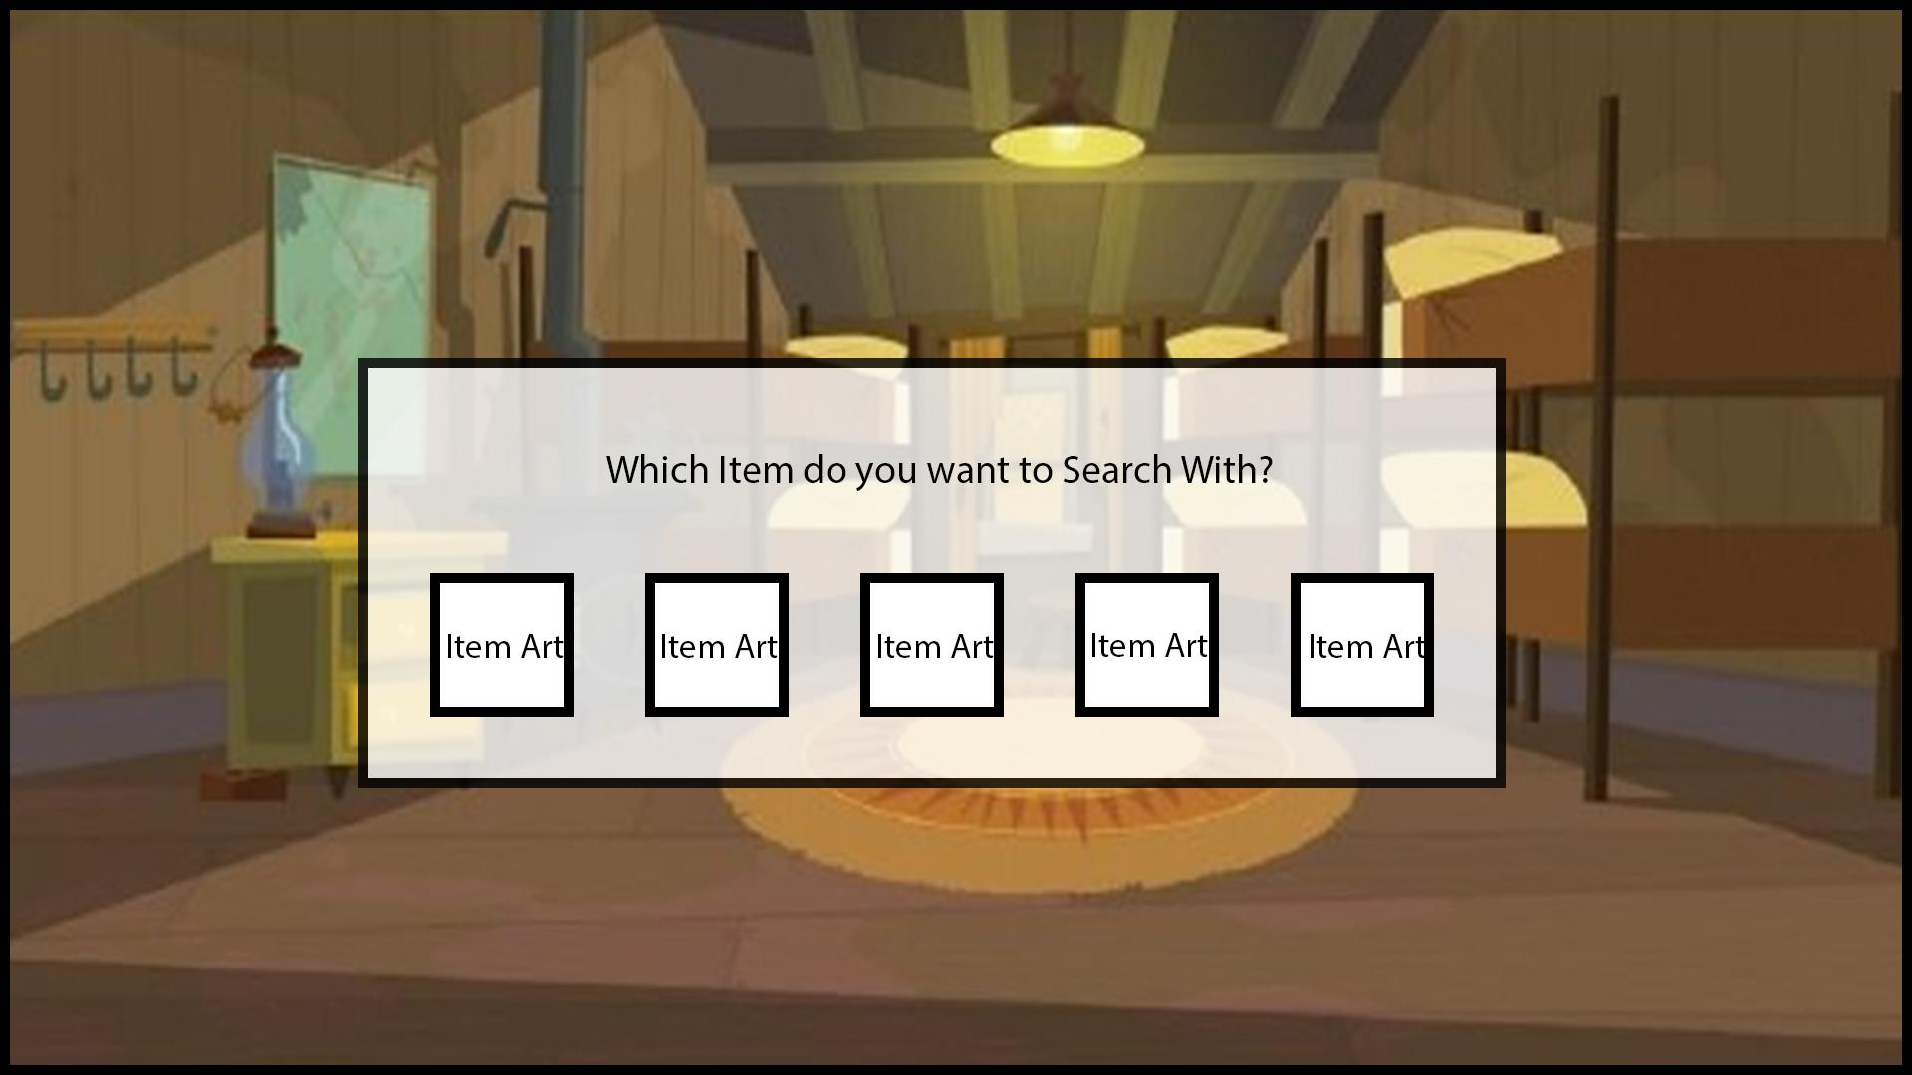
If the player chooses to look for the hidden stash, they will be asked to choose and which item they would like to sue to look for the stash. They can only use a getter item. The Result screen for finding the candy stash, is similar to the result screens above.

Interact with NPC
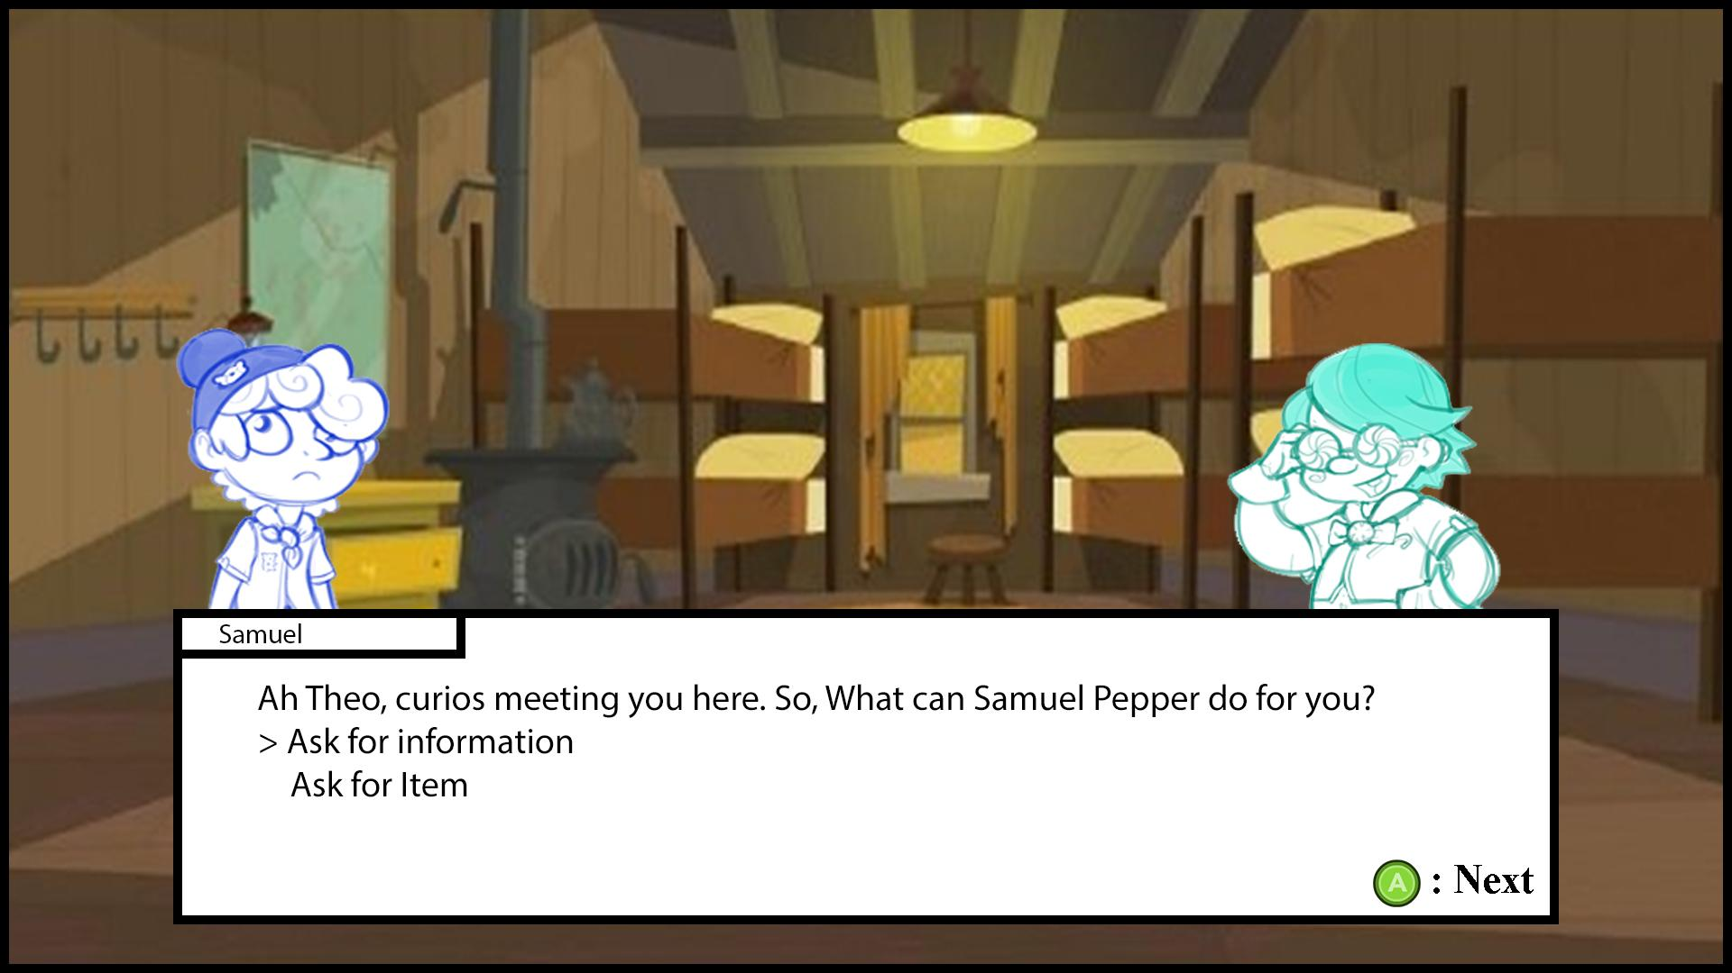
If the player chooses to interact with an NPC, it will bring up the dialogue menu. The active player's character will be on the left, and the NPC or limited Character will be on the right.
The player will be have two options: Ask the NPC for, or ask them for an item. How the NPC reacts will depend on their attitude.

Questioning Greedy Character
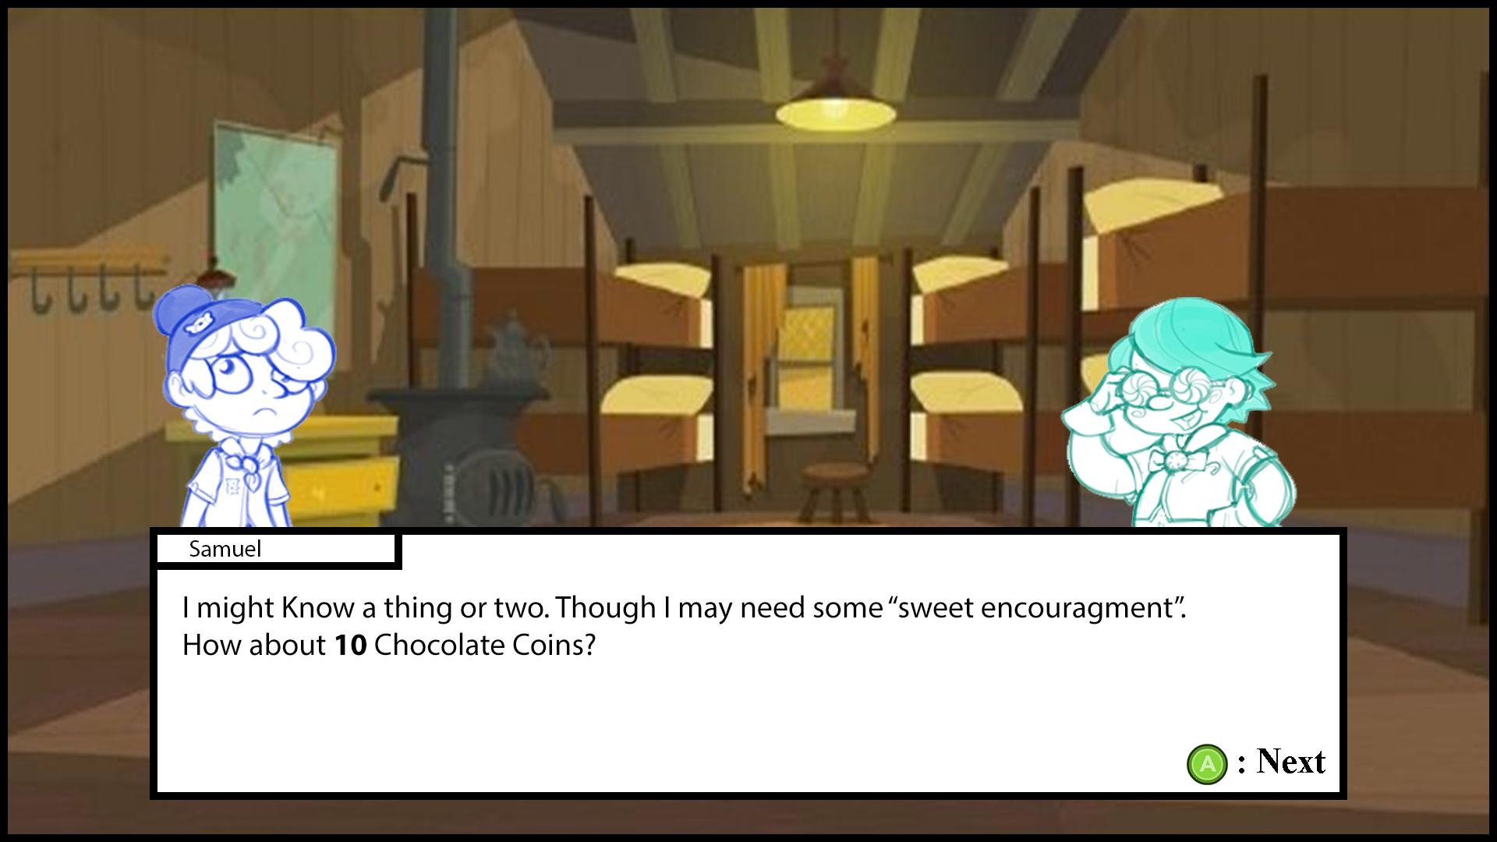
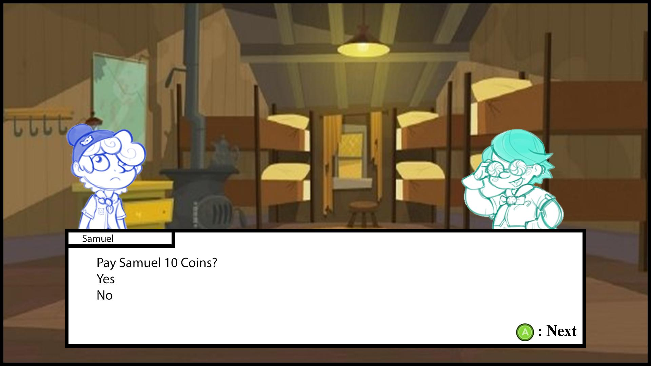
If the NPC is Greedy, they will ask the player for Chocolate Coins, in return for any items or Information they have.

Begin Accusation 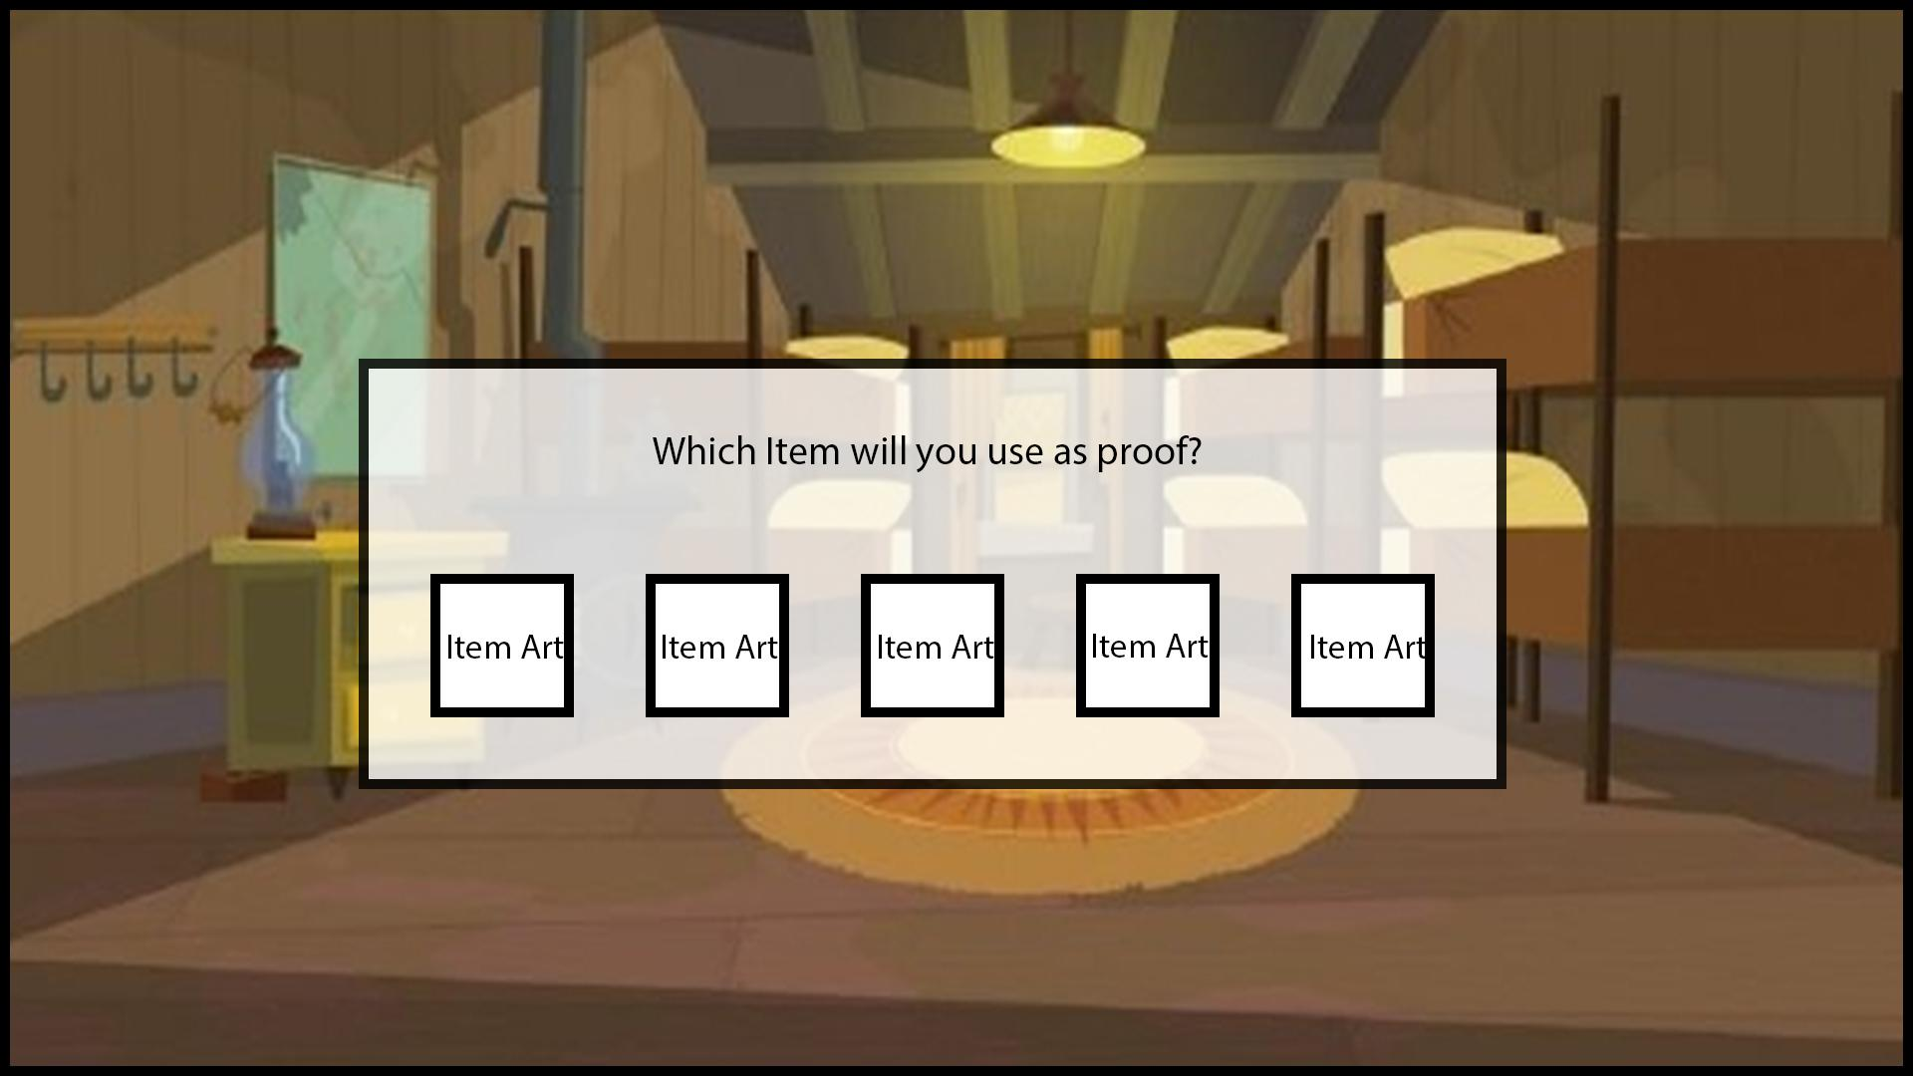
This screen will appear before the accusation screen. The player must select 1 Item as proof in their accusation before moving on to the next screen

Accusation
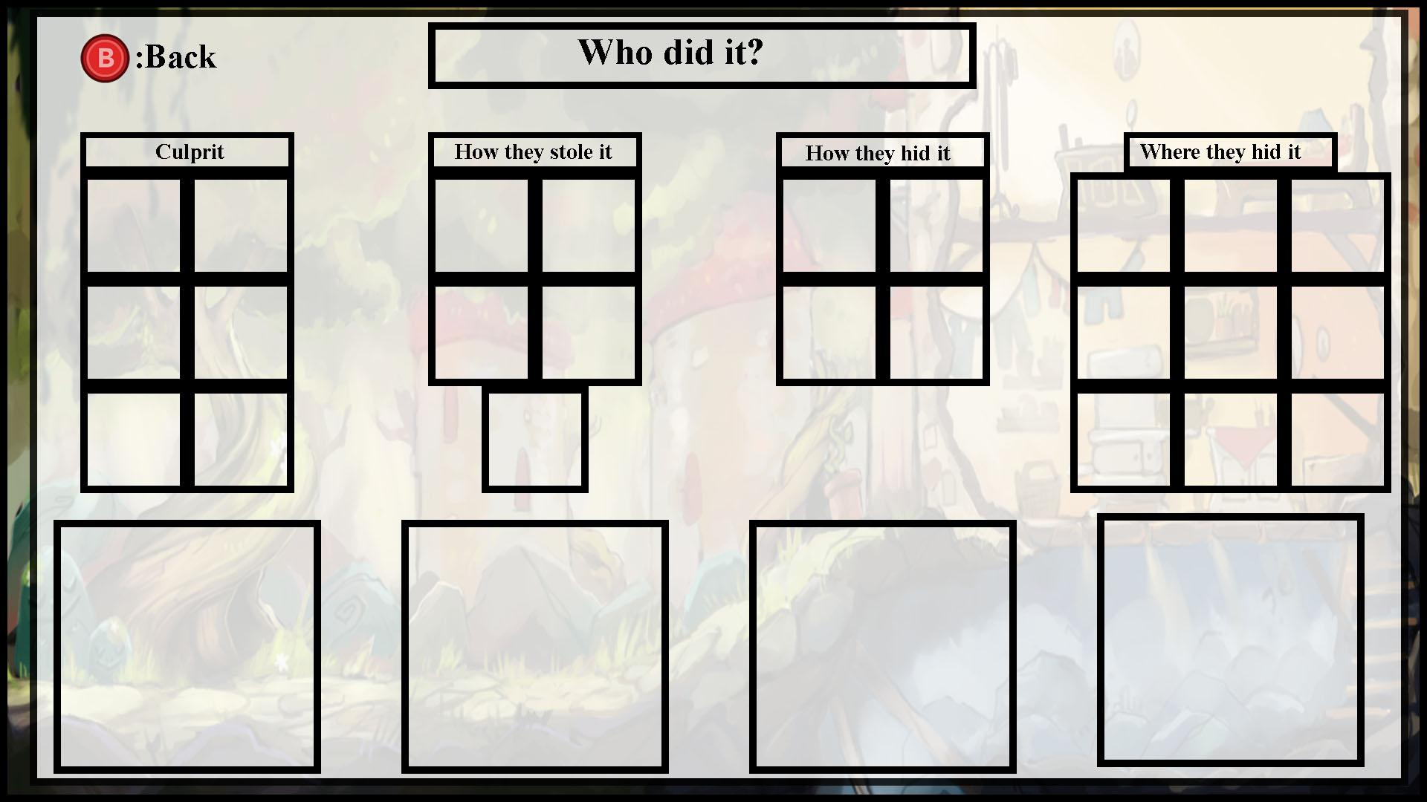
This menu can be reached when a player is inside of a Cabin Bunk. This is how a player can attempt to win the game by making an accusation of who the culprit is. The Player will be able to pick one option from each category from left to right. When the player picks an option: 1. the cursor will be moved from the category from the left to the right. 2. The option they chose in the previous category will be displayed in the larger box under that category. The player can presses [B] to go back and re-choose an option. If the player presses [B] while nothing has been chosen, they will be taken back to the Cabin Bunk Menu screen. Depending on the item the player uses to make the accusation, either the “How they stole it” or “How they hid it” will be chosen automatically

Version Notes
- Version 1.00 -9/19/2017- initial creation -Matthew.
- Version 1.01 -9/24/2017- Added Turn Order Breakdown (Section 5.0) - Matthew.
- Version 1.02 -9/25/2017- Updated Section 3.0 formatting. Removed all instances of bracketed “Candy” from Section 5.0. - Catherine
- Version 1.03 -9/26/2017- Added Character section 6.0 - Matthew.
- Version 1.04 -9/28/2017- Updated Section Numbers. Added Cabin and Rec Area list to section 3.3. Added GMD System explanation Section 4.0. Addition to section 3.4 (Limited Character placement), Correction to Section 5.0 (Conflict of information regarding Limited Character Placement) Added Wireframe section 7.0 - Matthew.
- Version 1.05 - 9/29/2017 - Updated Player Character Information (Starting Points). Added more WireFrame explanations - Matthew.
- Version 1.06- 9/30/2017 - Changed Character interaction UI - Matthew.
- Version 1.07- 10/2/2017 - Added 5.4 Brief Game Flow - Matthew.
- Version 1.08 - 10/03/2017 - Added Section 3.8 (Shortcut NPC), Bookmarked links to scripting priority list.- Matthew
- Version 1.09 - 10/5/2017 - Correction to Shortcut NPC section. Addition to Section 3.3 (NPC and player placement.) Unliked Bookmarks to Scripting list (Whole sections are now copied and linked internally within the scripting list) - Matthew
- Version 1.10 - 10/16-17 - Changed character P.B.’s and Slice’s attitudes from Tough to Friendly and Greedy, respectively. - Catherine
- Version 1.11 11/30/17 - Changed Topmost title to Sugar Sleuths, Renamed Document to Game Design Document: Sugar Sleuths. - VIA

